- 1.Launch oneEC2 instance using Amazon Linux 2:-
To launch one Amazon EC2 instance using Amazon Linux 2, follow these theory steps in the Amazon Web Services Management Console:

Step 1: Sign in to AWS Console
Open the AWS Management Console.
Log in using your AWS account credentials.
Search for EC2 in the services search bar.
Step 2: Open EC2 Dashboard
Click on EC2 service.
The EC2 dashboard shows running instances, security groups, key pairs, etc.
Step 3: Start Launch Instance Wizard
Click Launch Instance.
This opens the instance configuration page.
Step 4: Configure Instance Name
Enter an instance name.
Example:
my-linux-server

Step 5: Choose Amazon Machine Image (AMI)

Select:
Amazon Linux 2 AMI (64-bit x86)
AMI contains:

Operating system
Preinstalled software
Boot configuration
Step 6: Choose Instance Type
Select an instance type according to requirements.
Common free-tier option:
t2.micro
Features:
1 vCPU
1 GB RAM
Eligible for AWS free tier
Step 7: Create or Select Key Pair

A Key Pair (.pem file) is required for SSH login.
Options:
Create new key pair
Use existing key pair

Download:

mykey.pem

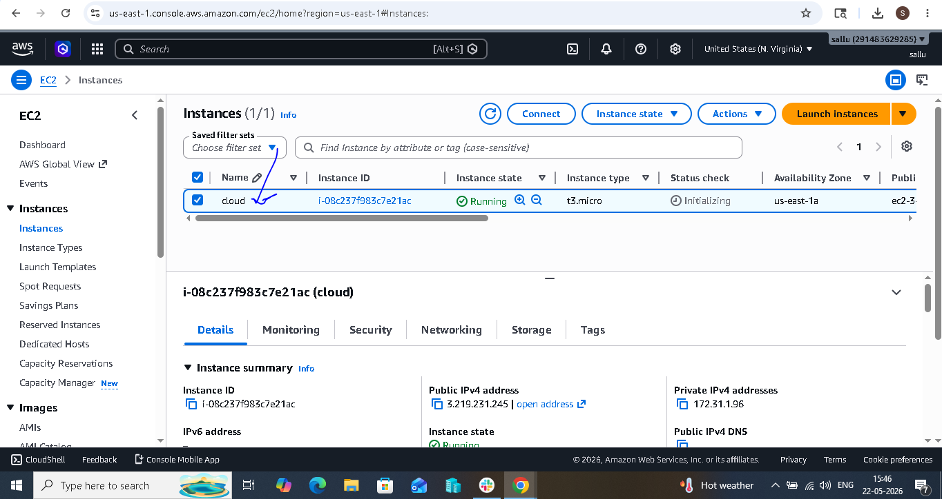

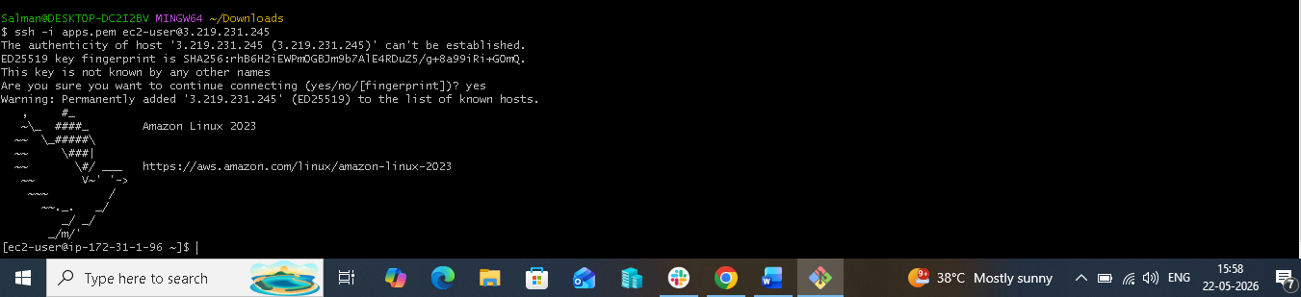

- 2.Install Docker:-

To install Docker on an Amazon Linux 2 EC2 instance, follow these theory steps:

Step 1: Connect to EC2 Instance

Login through SSH:

ssh -i mykey.pem ec2-user@Public-IP
mykey.pem → Key pair file
ec2-user → Default user for Amazon Linux 2
Public-IP → EC2 instance public IP address
Step 2: Update System Packages

Update installed packages before installation:

sudo yum update -y

Purpose:

Updates package lists
Installs latest security patches
Step 3: Install Docker

Install Docker package:

sudo yum install docker -y

This downloads and installs Docker Engine.

Step 4: Verify Docker Installation

Check Docker version:

docker --version

Example output:

Docker version xx.xx.x

This confirms Docker is installed.

Step 5: Start Docker Service

Start Docker daemon:

sudo service docker start

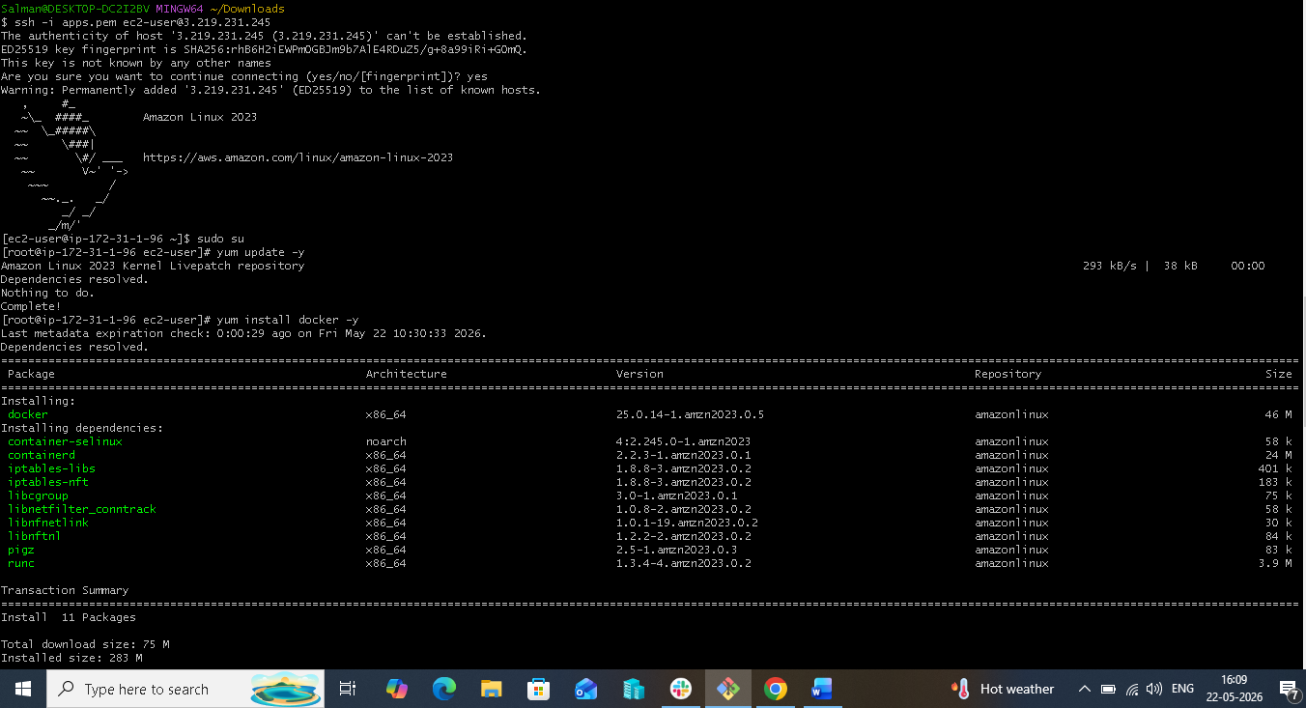

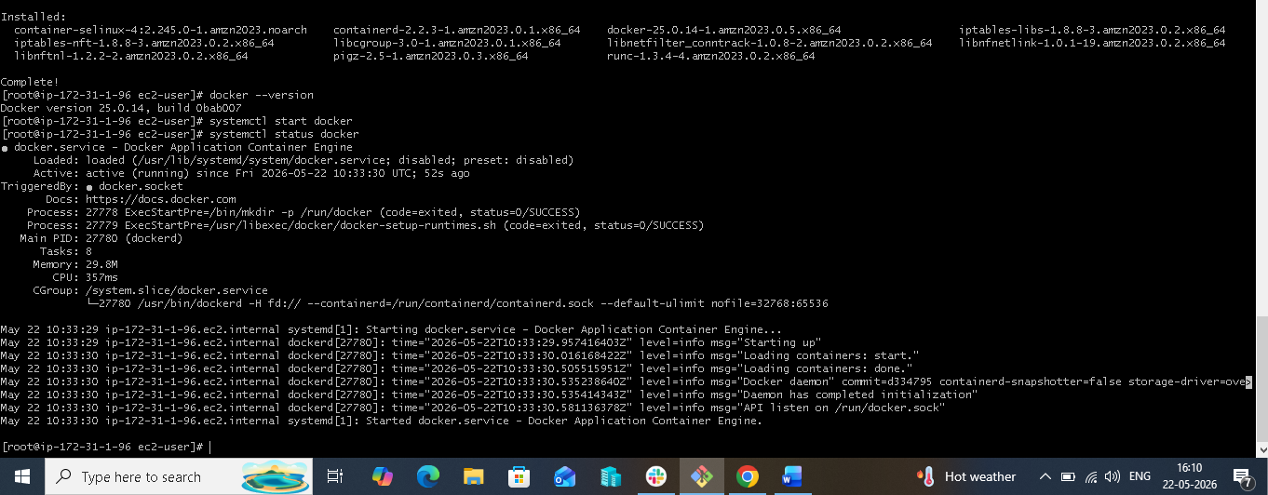

3. Install Jenkins:-

To install Jenkins on an Amazon Linux 2 EC2 instance, follow these theory steps:

Prerequisite

Before installing Jenkins, ensure:

EC2 instance is running (Amazon Linux 2)
Java is installed (Jenkins requires Java)
Docker is optional
Default Port 8080 is allowed in EC2 Security Group (for Jenkins UI)

Add inbound rule:

Type Protocol Port Source
Custom TCP TCP 8080 Anywhere (0.0.0.0/0)
Step 1: Connect to EC2 Instance

Login using SSH:

ssh -i mykey.pem ec2-user@Public-IP
Step 2: Update Packages

I installed the repo n packages with below commands and also change the port number as 8089.

sudo wget -O /etc/yum.repos.d/jenkins.repo \
https://pkg.jenkins.io/redhat-stable/jenkins.repo

then

sudo rpm --import https://pkg.jenkins.io/redhat-stable/jenkins.io-2023.key

To change port number path is:
$ Vi /usr/lib/systemd/system/jenkins.service
8080 to 8089 .

Update system packages:

sudo yum update -y

Purpose:

Installs latest updates
Fixes package dependencies
Step 3: Install Java

Jenkins needs Java runtime.

Install Java 17:

sudo yum install java-17-amazon-corretto -y

Check installation:

java -version

Expected output:

openjdk version "17"
Step 4: Add Jenkins Repository

Enable Jenkins package repository:

sudo wget -O /etc/yum.repos.d/jenkins.repo \
https://pkg.jenkins.io/redhat-stable/jenkins.repo

Import Jenkins key:

sudo rpm --import https://pkg.jenkins.io/redhat-stable/jenkins.io-2023.key

Purpose:

Allows secure Jenkins installation
Step 5: Install Jenkins

Install package:

sudo yum install jenkins -y

This downloads:

Jenkins service
Required dependencies
Step 6: Start Jenkins Service

Start Jenkins:

sudo systemctl start Jenkins.

After installing Jenkins go to browser put url:- instance ip address and port number of Jenkins:- http://3.219.231.245:8089/

Then will get path in browser copy that path and go to git bash do cat and paste the path, you will get one key copy that key and paste into the browser. Then fill user name and keep password then you will get the Jenkins page given below:-

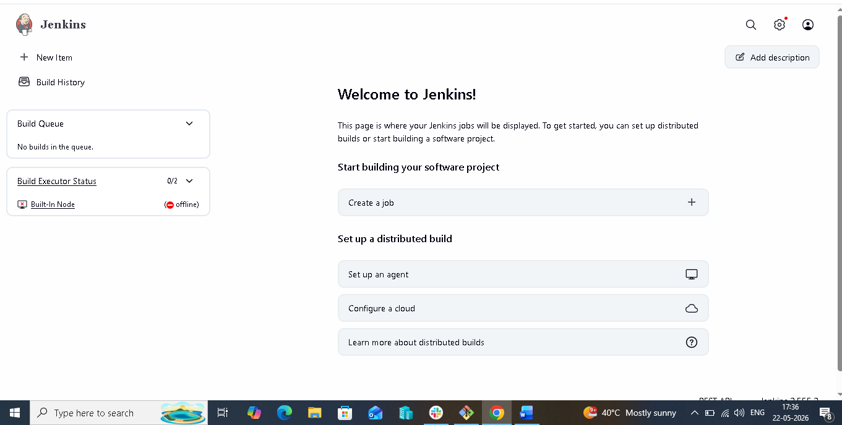

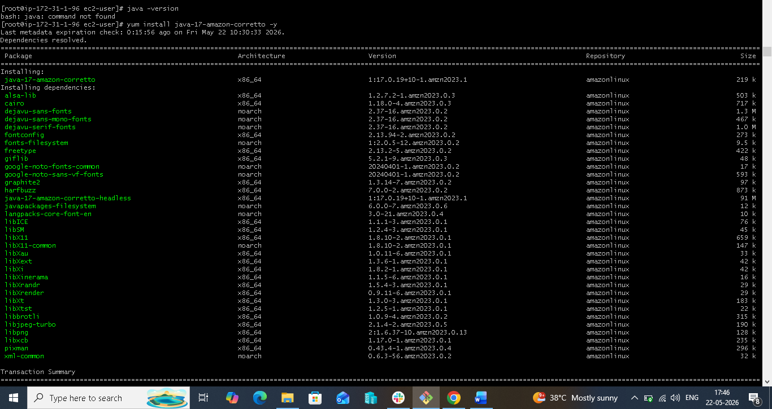

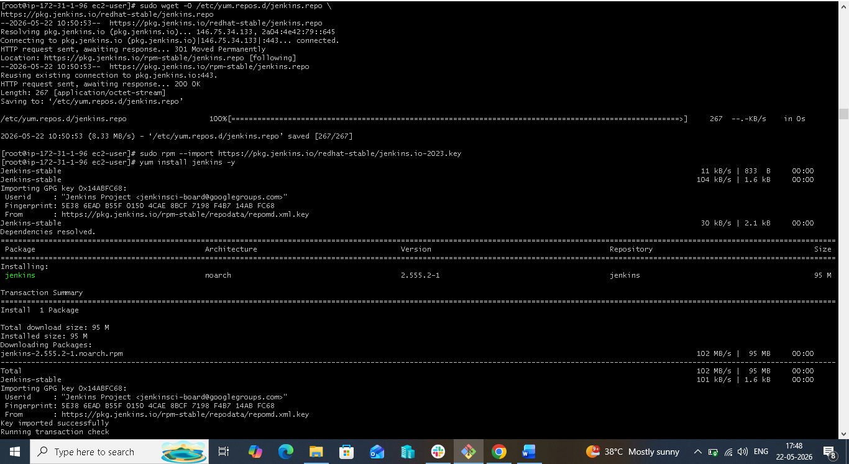



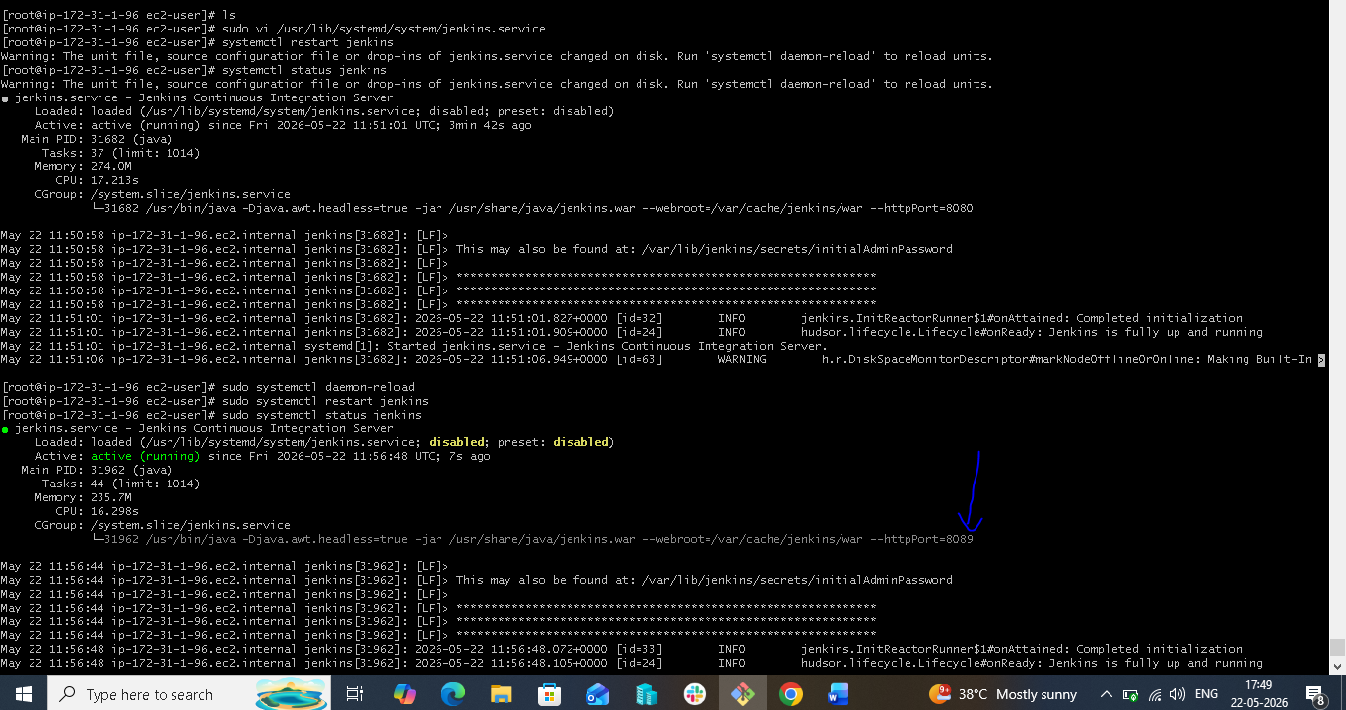

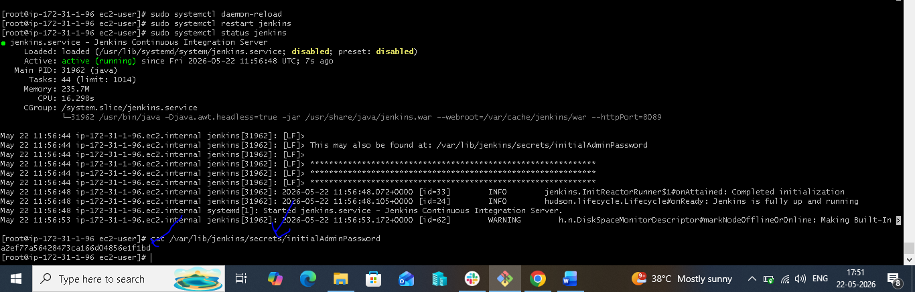

- Install Apache httpd:-

To install Apache HTTP Server (httpd) on Amazon Linux 2, follow these theory steps:

Step 1: Connect to EC2 Instance

Login through SSH:

ssh -i mykey.pem ec2-user@Public-IP

Purpose:

Access Linux server remotely
Step 2: Update System Packages

Update package repository:

sudo yum update -y

Purpose:

Install latest package updates
Improve security and compatibility
Step 3: Install Apache (httpd)

Install Apache server:

sudo yum install httpd -y

httpd = Apache HTTP Server package in Linux

Step 4: Verify Installation

Check Apache version:

httpd -v

Example output:

Server version: Apache/2.4.x

This confirms installation.

Step 5: Start Apache Service

Start Apache server:

sudo systemctl start httpd

then to check in browser I change port number first from default port 80 to 81 by using find command I search the path then I edited the port number to 81.

find / -name "httpd.conf" then
do
vi /etc/httpd/conf/httpd.conf to change the port number.

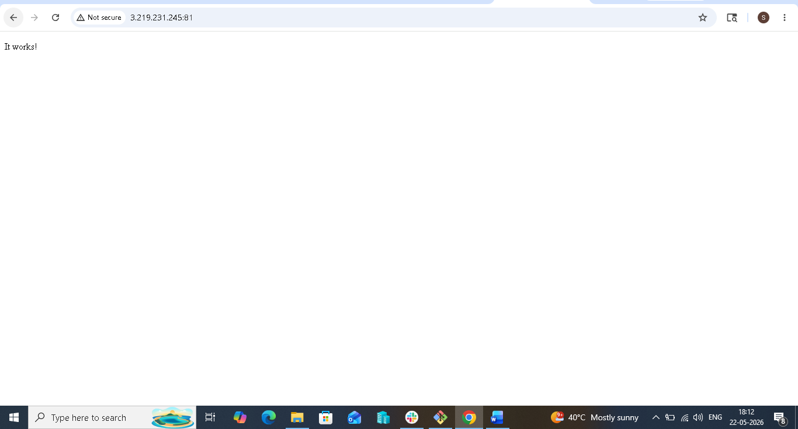

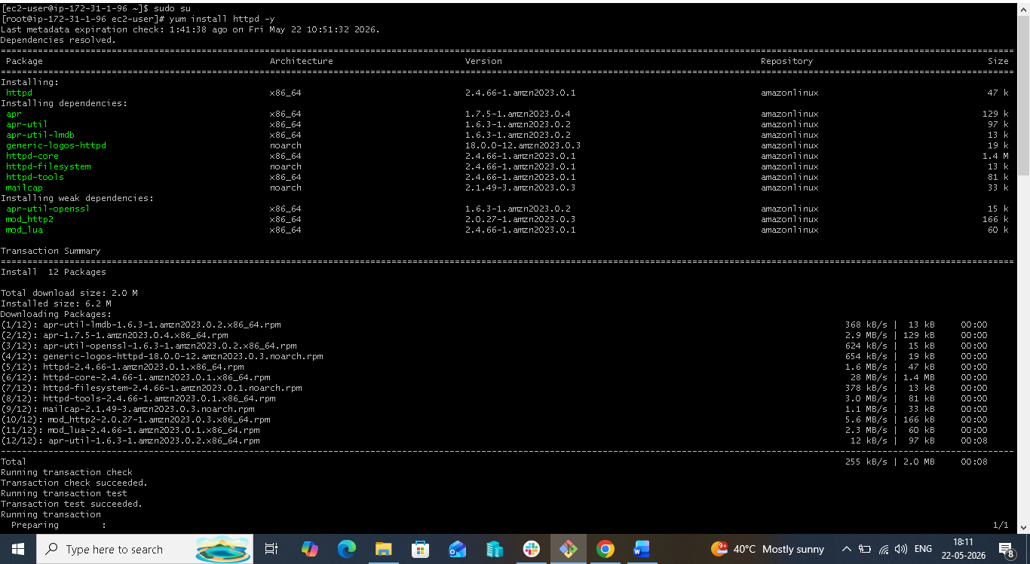

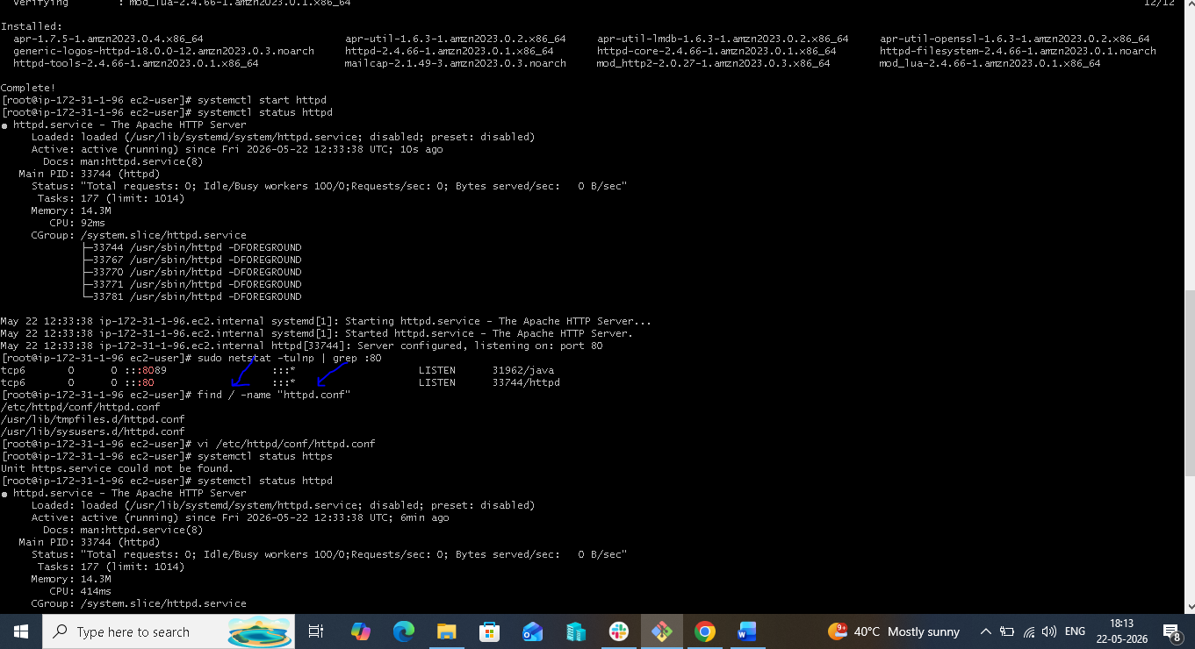

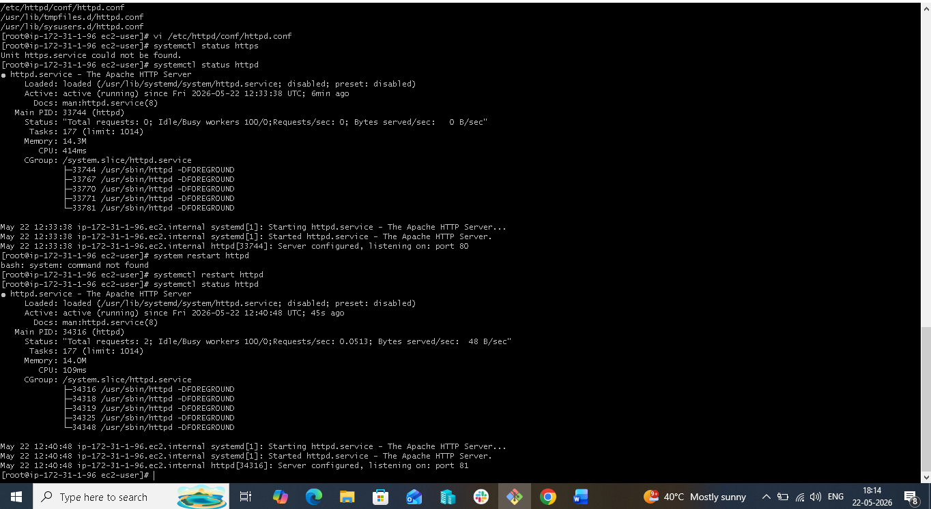

4.Install Nginx:-

To install Nginx on a Linux server (Amazon Linux 2 / EC2), follow these theoretical steps:

Step 1: Launch and Connect to EC2 Instance
Create an EC2 instance using Amazon Linux.
Download the .pem key pair.
Connect using SSH:
ssh -i mykey.pem ec2-user@Public-IP

Purpose:

Access the Linux server remotely.
Step 2: Update System Packages

Update all installed packages:

sudo yum update -y

Purpose:

Install latest security updates
Refresh package metadata
Step 3: Install Nginx Package

Install Nginx using package manager:

For Amazon Linux 2:

sudo amazon-linux-extras install nginx1 -y

or:

sudo yum install nginx -y

Purpose:

Downloads and installs Nginx software

To check nginx is started or not we have below command:
Systemctl start nginx
To check nginx is started or not we have below command:
Systemctl status nginx

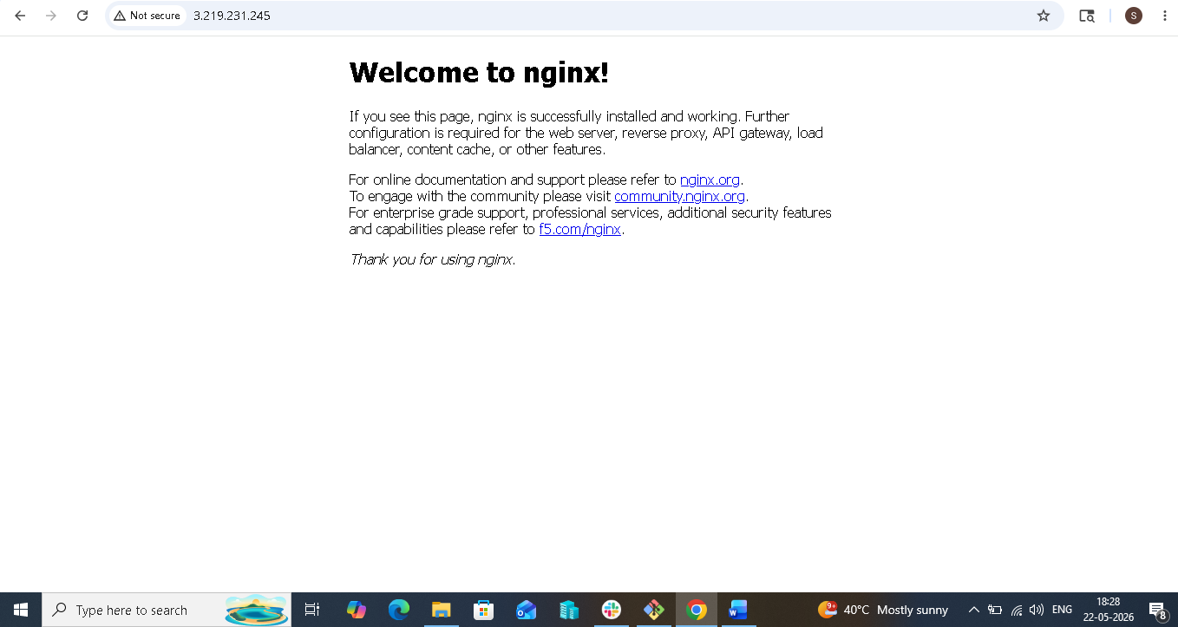

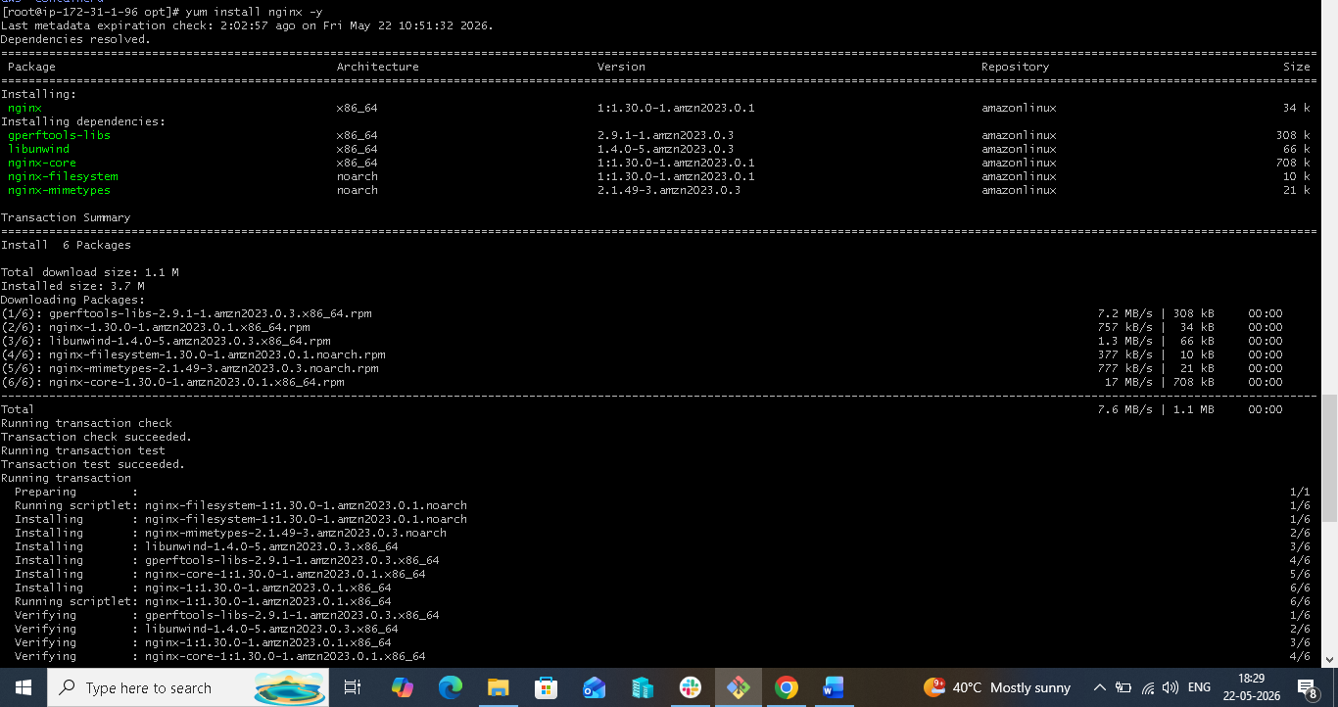

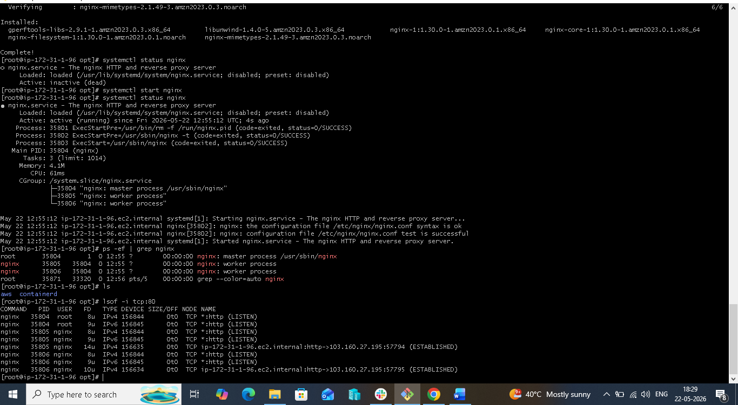

- Install Apache Tomcat:-

To install Apache Tomcat on Amazon Linux 2 / EC2, follow these theoretical steps:

What is Apache Tomcat?

Apache Tomcat is an open-source web server used to run Java applications, Servlets, and WAR files.

Default Tomcat port:

8080 but I changed the port number to 8081 by below command:-

sudo vi /opt/tomcat/conf/server.xml

Step 1: Launch EC2 Instance
Open AWS Console.
Launch an EC2 instance with Amazon Linux 2.
Configure Security Group:
Allow SSH (22)
Allow Custom TCP (8080) for Tomcat access

Purpose:

Create Linux server environment.
Step 2: Connect to EC2 Instance

Use SSH:

ssh -i mykey.pem ec2-user@Public-IP

Purpose:

Access server remotely.
Step 3: Update System Packages

Update package repository:

sudo yum update -y

Purpose:

Install latest package metadata and security updates.
Step 4: Install Java (Prerequisite)

Tomcat requires Java.

Install Java 17:

sudo yum install java-17-amazon-corretto -y

Verify:

java -version

Expected:

openjdk version "17"

Purpose:

Java runtime required for Tomcat execution.

Download Tomcat package from official source.

wget https://downloads.apache.org/tomcat/tomcat-9/...this will get in browser by searching tomcat download.

Purpose:

Obtain Tomcat binaries.
To start the tomcat after changing the port first shutdown and then start the tomcat service with below path:-
/opt/tomcat/bin/
In above path we get script to start like startup.sh and to shutdown is shutdown.sh
Just keep ./startup to start the tomcat services.

